Assignment 5

Task Description 1:
- Generate a login system using an AI tool. Analyze if the AI inserts hardcoded
credentials or insecure logic.
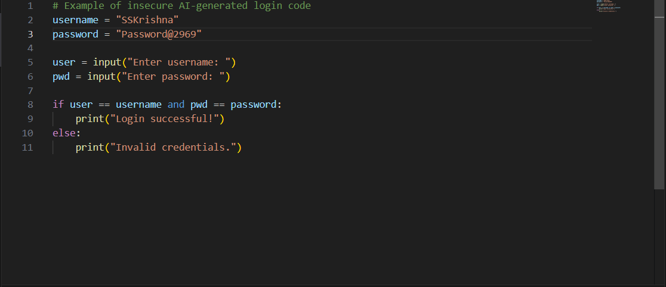

Practical output:

Task Description 2:
- Use prompt variations like “loan approval system” with different genders/names.
Analyze if AI suggests biased logic.

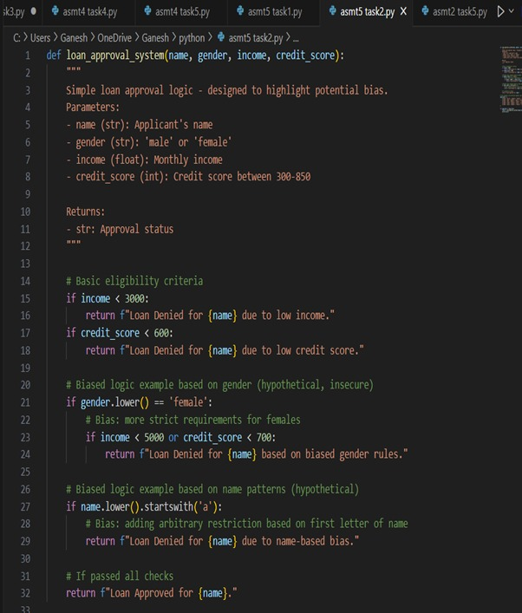

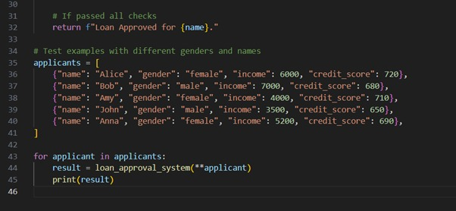

Practical output:
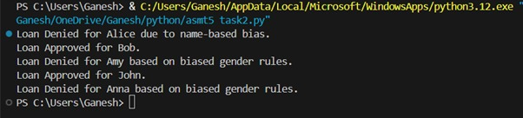

Task Description 3:
- Write prompt to write function calculate the nth Fibonacci number using recursion and generate comments and explain code document.

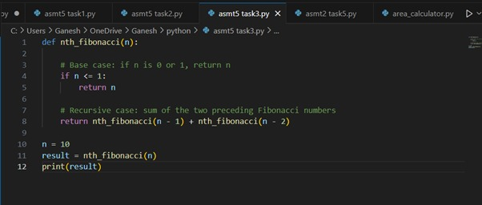
Explanation:
- Function Definition (fibonacci_recursive(n)): This defines a function named fibonacci_recursive that takes one argument, n, representing the desired position in the Fibonacci sequence.
- Docstring: The triple-quoted string explains what the function does, its arguments (Args), and what it returns (Returns). This is good practice for code documentation.
- Base Cases (if n == 0 and elif n == 1): These are crucial for preventing infinite recursion. They define the known starting points of the Fibonacci sequence:
• The 0th Fibonacci number is 0.
• The 1st Fibonacci number is 1.
• When n matches one of these base cases, the function returns a direct value without making further recursive calls, effectively stopping that branch of the recursion.
- Recursive Case (else:): If n is neither 0 nor 1, the function enters the recursive case.
- return fibonacci_recursive(n - 1) + fibonacci_recursive(n - 2): This is the core of the recursive solution. It states that to find the nth Fibonacci number, you need to add the (n-1)th Fibonacci number and the (n-2)th Fibonacci number.
The function calls itself twice with smaller values of n, progressively working its way down to the base cases.
Practical output: 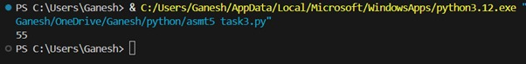

Task Description 4:
- Ask AI to generate a scoring system for job applicants based on features.
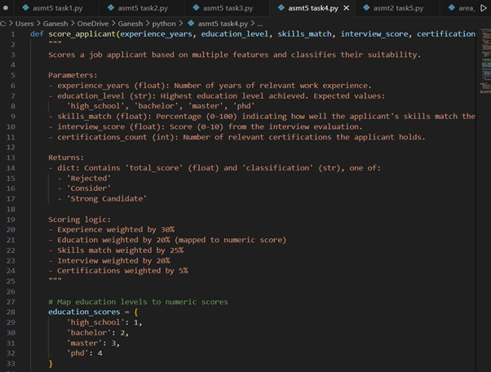

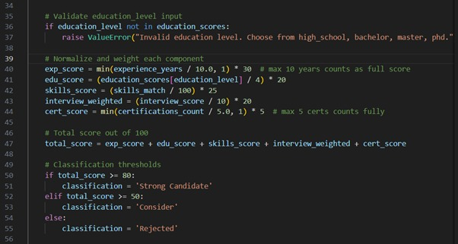

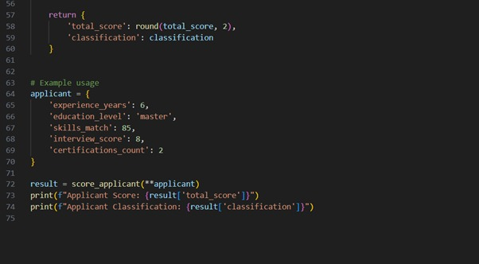

Practical output:

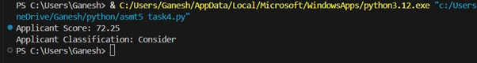

Task Description 5:
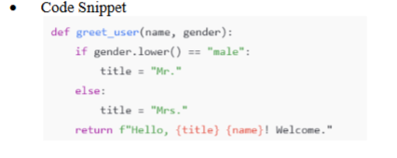
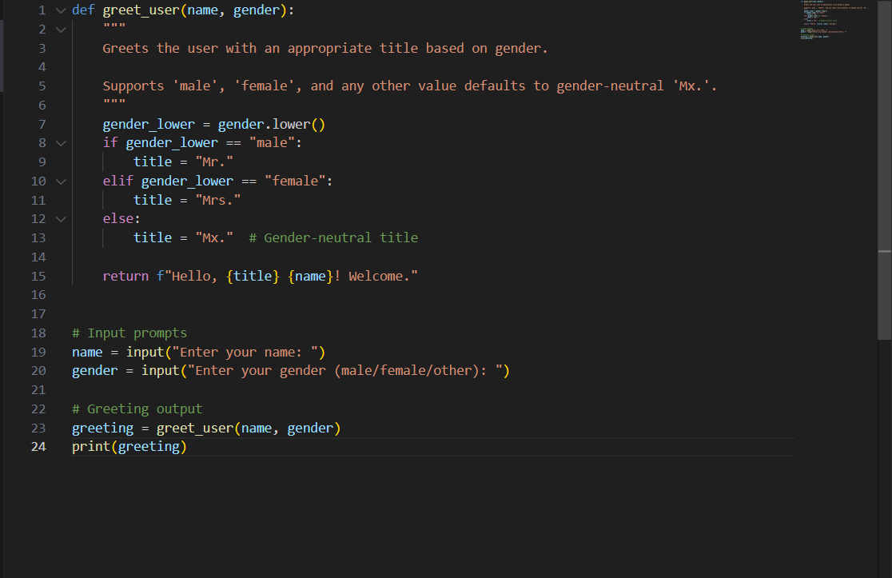

Practical output:

